JHA QuickAssist: Cheat Sheet
Placing Travel Notes:
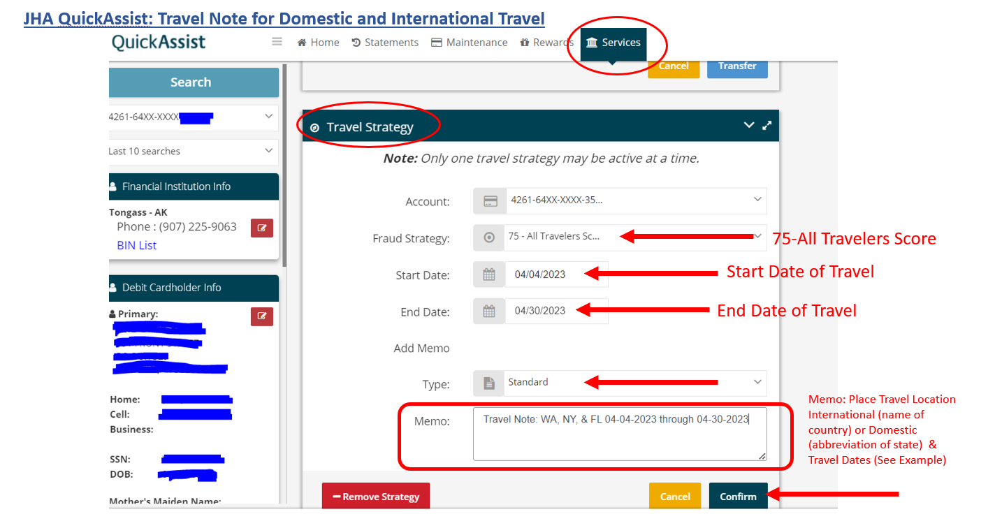
Placing Card in ‘COOL DOWN’ PERIOD:
(This will be used after a cardholder has verified the transaction that was picked up as ‘WARM RESTRICTED’ or ‘HOT PICKUP’ NOT FRAUD. The transaction was done by the card holder.)
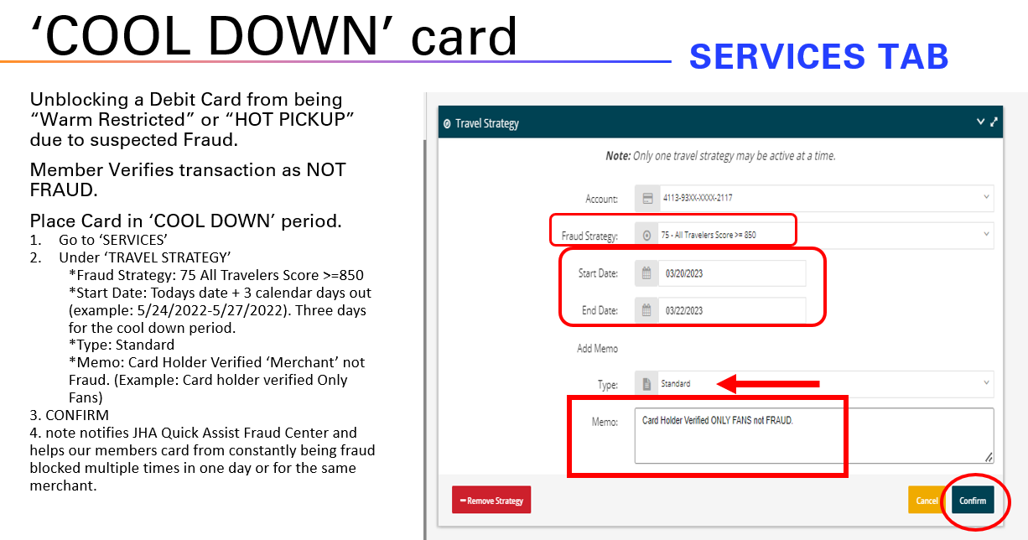

Rest PIN Attempts:
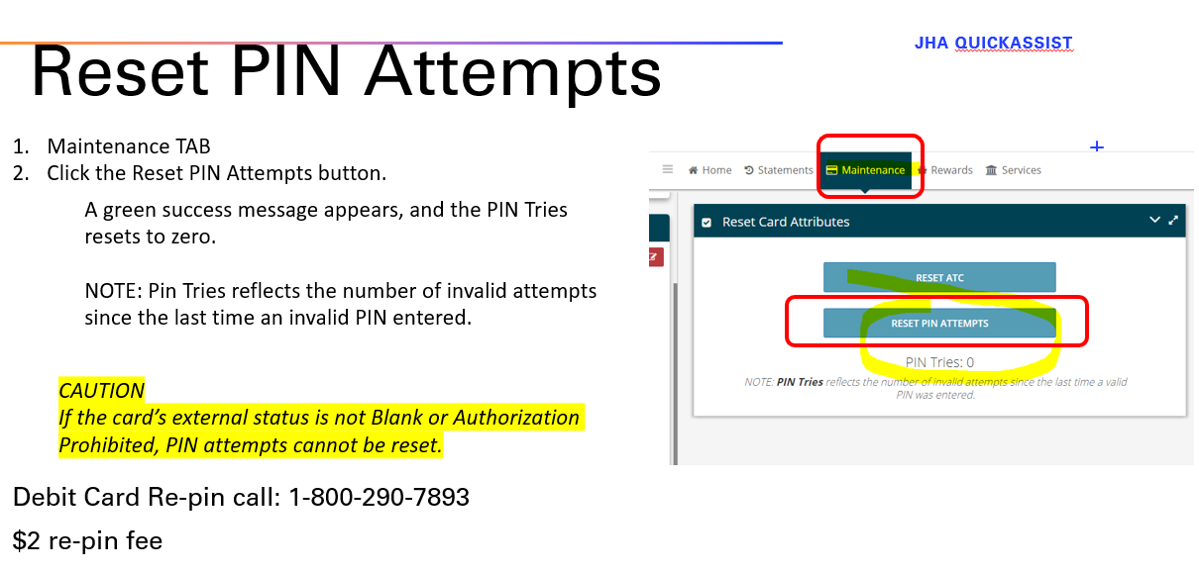
Updating Cardholder Information:
(Change to match Gold or if information is incorrect in JHA QuickAssist)
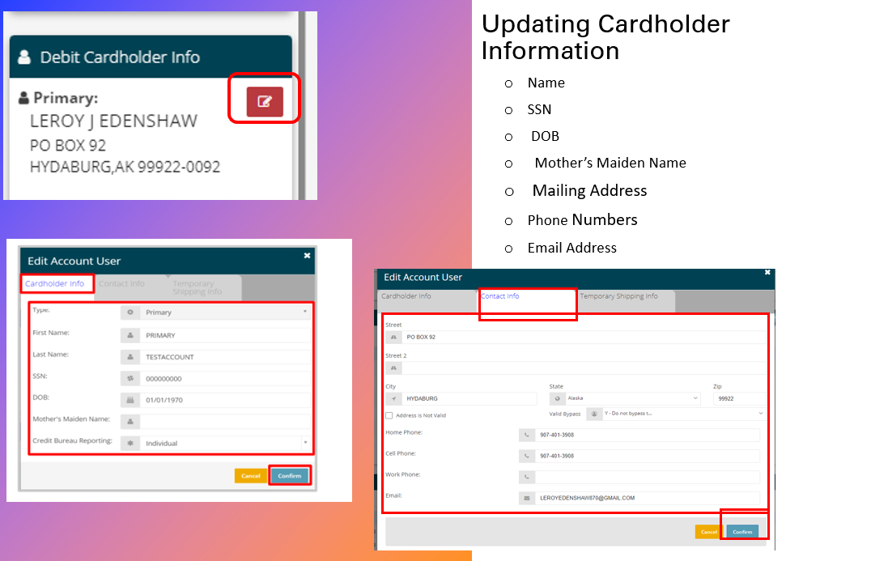

Blocking a Card in JHA QuickAssist:
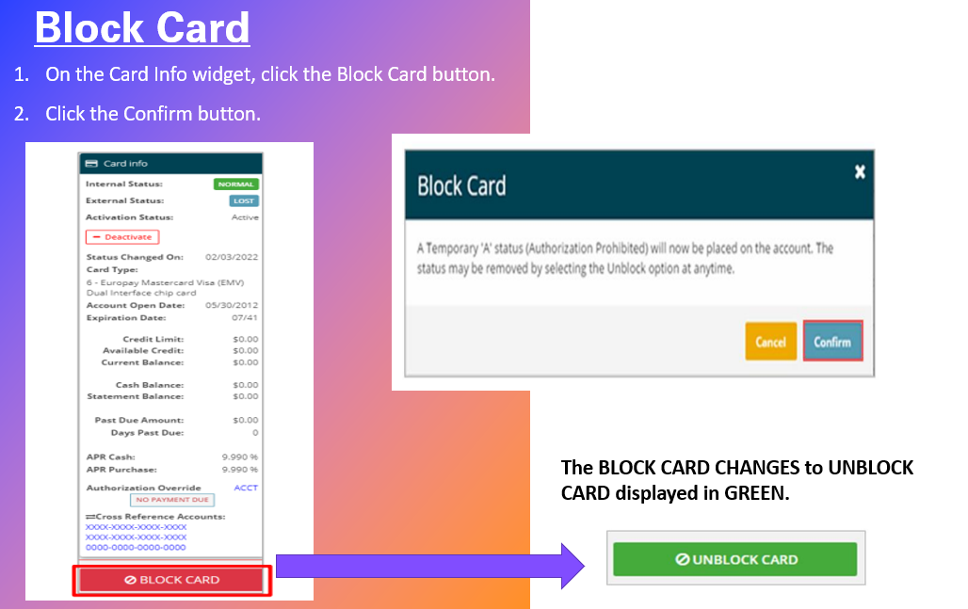
UNBLOCKING a Card in JHA QuickAssist:
